Java Code:

DrawPanel.java

import javax.swing.JFrame;
import javax.swing.JPanel;
import java.awt.Color;
import java.util.Random;
import java.awt.*;

public class DrawPanel extends JPanel{

private Color colors[] =
{ Color.WHITE, Color.BLUE, Color.GREEN, Color.YELLOW, Color.ORANGE, Color.RED };

public DrawPanel () {
setPreferredSize(new Dimension(1000, 1000));
this.setBackground(Color.black);
}

public void paintComponent(Graphics page) {
super.paintComponent(page);

for(int b = 0 , x = 6; b<500 ; b+=3 , x+=2) {
page.setColor(colors[(int)(Math.random()*6)]);
page.drawArc(b + 150, x, 100, b^x, b, 360);
}

for(int c = 0; c<500 ; c+=1) {
page.setColor(colors[(int)(Math.random()*6)]);
page.fillRoundRect(0,200,c^c-1,c^c-1,c*c,c*c);
}
}
}

Drawing.java
import javax.swing.JFrame;
import javax.swing.JPanel;
import java.awt.*;

public class Drawing{
public static void main(String[] args) {
JFrame frame = new JFrame("Drawing");
frame.setDefaultCloseOperation(JFrame.EXIT_ON_CLOSE);
DrawPanel p = new DrawPanel();
frame.getContentPane().add(p);
frame.pack();
frame.setVisible(true);

}
}
RESULT:
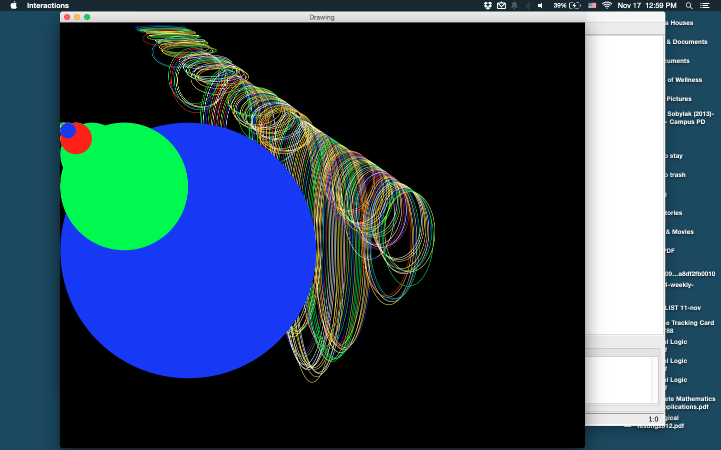

I have not gotten to chapter 7 in iJava yet, because it is not due.

